BIG Summer Newsletter 2019

What’s been going on?

The 2019 Annual General Meeting

The 2019 Annual General Meeting of the Brain Injury Grampian (BIG) Group was held at Inchgarth Community Centre on 15th May.
The meeting was well attended with a lively discussion on the future direction and organisation for BIG.
2 New members were voted on to committee – Susan Irvine and Amy Shand. The first committee meeting held in June looked at the committee structure and established a sub-committee regime which will enable us to continue delivering our full social support programme but with responsibilities/tasks better spread among committee members and volunteers.
Sadly we had to take our leave of Liz and Larry Gray – founder members of BIG who are moving south to be nearer family. Ian presented them with a small parting gift as a show of our appreciation for all that they have done for BIG.

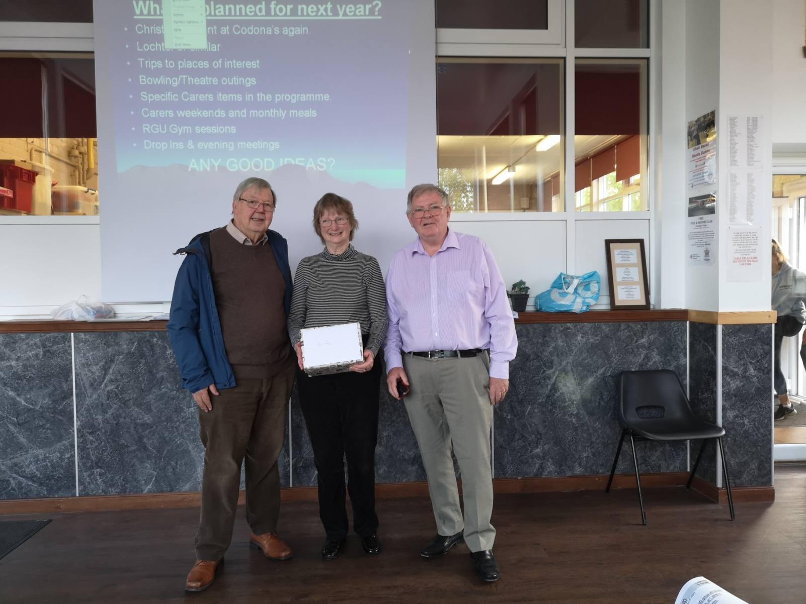

Lochter Activity Day
What a Day!!

Over 70 members and family attended our annual activity day on May 19th. This was the highest BIG attendance ever. On the day everyone enjoyed the activities – Go-karting, Blindfold 4 wheel driving, Archery, Digger Driving. Lochter also put on Segway (by request) and there were rods available for those who wanted to fish. The weather was very kind to us.
This is always a highlight of the year and 2019 was no exception

BIG Group Annual Dinner at Palm Court Hotel

61 members and guests attended on the evening of 19th of June. We had an excellent night. Good food and good company. We were entertained by Alisdair MacDonald on the bagpipes and Alec Thompson-Miller on the fiddle. Thanks to Ali and Alec and also to all who contributed so handsomely to the purchase of Raffle Tickets and the Donations Box, in total raising nearly £700 for our funds.

BIG Drop-Ins

Christine Kennedy and Jimmie Dickie have now taken over the organisation and running of the fortnightly Drop-Ins. For the coming year they will be assisted by a team of volunteers – Colin and Jackie Main, Ann Crombie and Maureen Smith (Chris’ mother)
Over the summer months (July and August) we will only have 1 Drop-In each month. These will be a great opportunity to meet, have a chat, a nice lunch and meet up with old friends. There will be no Art or Music and Laughter sessions at these summer Drop-Ins. As normal we will meet at Inchgarth Community Centre from 12 noon until 3 p.m.
The normal fortnightly Drop-Ins will recommence on the 2nd Friday in September (13th) including a Music and Laughter session.
Art and Music and Laughter Sessions will be incorporated at alternate Drop Ins. The format will continue to be very informal – Tea, coffee, soup and sandwiches with the opportunity to have a chat, play games, pool etc and get involved in the Art/Laughter sessions if you wish, so, come along, have a light lunch and a good laugh!!

July | Friday 12th
August | Friday 9th
September | Friday 13th M&L | Friday 27th Art
October | Friday 11th M&L | Friday 25th Art

If you would like to attend or have any queries about the Drop-Ins please contact Christine on 01651 891771 or Jimmie on 07875 234891.

Bowling:
Aberdeen bowling will continue to take place on the 1st Thursday of each month 7- 9PM at Codona’s at Aberdeen Beach. The next 2 months dates are 4th July and 1st August. If you would like to be involved just turn up or contact David Bowie on 01224 732607.

Lady Carers Bar Supper
For detail on the next Lady Carers Supper please give Christine Lewis a ring on 07974855134.

Male Carers Meal
The male carers group’s next meal is on Friday 19th July at the Light of Bengal Restaurant at 13 Rose Street at 7pm.
All male carers are invited and will be made very welcome. If you would like to come along and join us get in touch with Ali MacDonald on 01224 783339

Future Events

Sunday 4th of August
Steam Train Trip with Afternoon Tea

For our main summer event this year we are arranging a coach trip to Aviemore to board the Strathspey Railway steam train on a return journey from Aviemore to Broomhill. Afternoon Tea will be served as we steam through the highlands.
We leave Aberdeen at 9.30 picking up at various locations arriving at Aviemore around 12.30

The projected timetable is:-
Bus leaves Spa Street Aberdeen 09.30
Westhill – Layby at Police Station 10.00
Inverurie – Town Hall 10.30
Huntly – ASDA car park (possibly) 11.15
Aviemore – Walk round – bite of lunch 12.30 (ish)
Board Steam Train 14.45
Afternoon Tea 15.00
Return Aviemore 16.25
Bus to Aberdeen with Drop Offs 16.30

Times/Pick-ups etc will be confirmed individually prior to the event.
This event is now fully booked but if you would still like to book a place and haven’t yet been in touch please contact Ian on 01224 733941and we will see what we can do.

September 18th (Wednesday)
Autumn Quiz Challenge
Come along and join us. Bring a team and challenge for the Joke Wardle Memorial Trophy. We hope to, again, secure the services of “world famous” quizmaster Carol Innes for a general knowledge quiz.
Good fun, good company, huge prizes?.
Meet at Inchgarth 7.30 p.m.

September 20th to 22nd
BRAW 2019

14 members have already applied for BRAW places. We still have 1 place available, so, if you would like to come along please contact Ian on 01224 733941 ASAP
If we receive more than 1 additional applicant we will try (but cannot guarantee) to secure further places.
Lady Carers Weekend
Easter Bendochty, Blairgowrie – 4th to 7th October
These weekends have been a regular feature on our programme for quite a few years. Those who attend find the weekends very beneficial and a real break from their caring duties in the company of others with the same challenges at home.
We would love to welcome any new faces to our next weekend in October. You can join in the fun or relax on your own whatever you feel like doing.
Easter Bendochty House is really nice with lots of facilities and things to do.
The weekend is for 3 nights, but, if you would like to come only for 1 or 2 nights (or even just a day visit) then that is fine.

If you would like to find out more about the weekends and are interested in coming along give Isobel Buchan a ring on 07739029904 or email izzybuc@hotmail.co.uk

2019/2020 Programme

The new committee is actively working on the 2019/2020 Programme. The next Newsletter will be in September and, hopefully the programme will be complete and included.

Support groups:

The BIG “Team Horizons” support group meets from 11 a.m. on the last Wednesday of each month at “The Fine Peace” Café just behind Horizons in Eday Road.
The Elgin support group meets the last Monday of the month at 11 AM at the Moray resource centre, Maisondieu Road, Elgin, IV30 1RX.
The Inverurie support group meets on the last Friday of the month in the Discussion Room at the Garioch Community Centre, Victoria Street, Inverurie, 1-3 PM.

For further details phone Ian (01224 733941), or Chris (07948 609783) for the Aberdeen group, Lois for the Elgin group (01343551339) and Carol for the Inverurie group (07512667250).

BIG contact details
BIG group website: brain-injury-grampian.weebly.com
BIG group email: info.biggroup@gmail.com
BIG group mobile: 07532 186155
BIG group postal address: ℅ Digby Brown, 220 Union Street, Aberdeen, AB10 1TL
BIG is a registered charity, Scottish Charity number: SC032273

