BIG February Newsletter 2019

What’s been going on?

Our BIG Christmas “Shindig”
Our Christmas trip to Codona’s on 13th December was the best attended BIG event ever with 55 members attending. We had a great day with a lovely meal, a shot on the Dodgems, Karaoke and Ten Pin Bowling.
The raffle and donations totalled over £400 which will go to offset the cost.
Feedback was very positive. It is likely that we will be back at Christmas 2019

BIG Burns Night

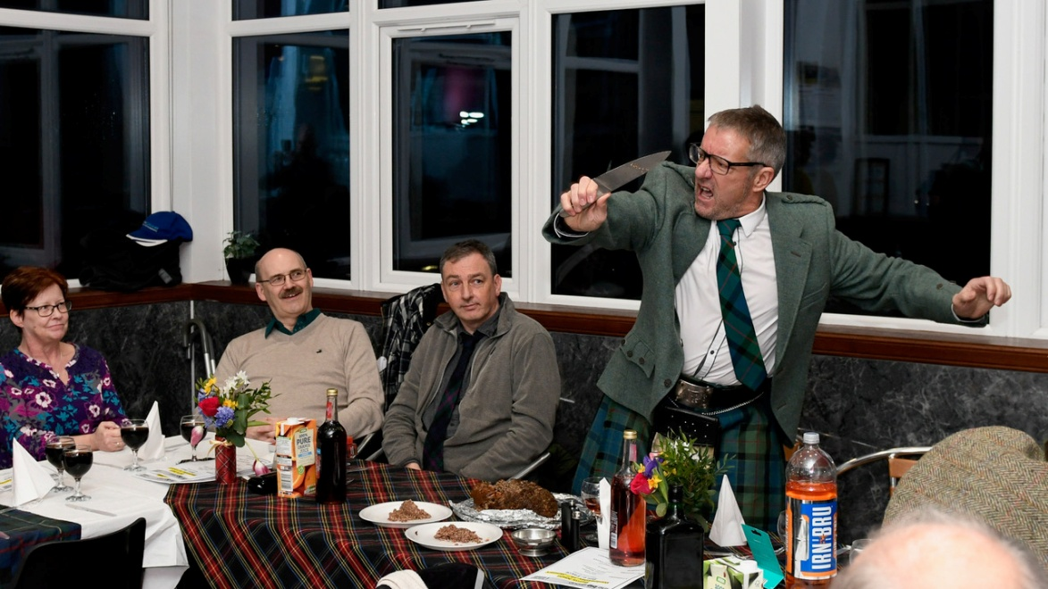

What a great night!! Our 1st ever Burns Supper was a roaring success. A really superb 2 course meal was prepared by Christine Kennedy and her team. Ali MacDonald piped in the Haggis, John Nicoll gave the “Address to the Haggis” with some style and Jimmie Dickie gave an excellent “Immortal Memory”.
Prior to the meal we had a Scots Quiz from Quizmaster Carol Innes.
We will certainly do this again! Thanks to all who contributed.

BIG Drop-Ins
The next Drop In is this Friday 25th January from 12 ‘til 3 and will be fortnightly thereafter as detailed below. Art and Laughter Therapy will be incorporated at alternate Drop Ins. Friday 25th incorporates an Art Session and the usual games, pool etc, so, come along, have a light lunch and a good laugh!!

LAUGHTER THERAPY ART SESSIONS
February | Friday 8th | February | Friday 22nd
March | Friday 8th | March | Friday 22nd
April | Friday 5th | April | Friday 19th

If you would like to attend but transport is a problem please contact Ian on 01224 733941 and we will try to help.
Bowling:
Aberdeen bowling will continue to take place on the 1st Thursday of each month 7- 9PM at Codona’s at Aberdeen Beach. The next 2 months dates are 7th February and 7th March. If you would like to take part just turn up or contact Ian on 01224 733941.

Lady Carers Weekends
A lovely weekend was had by all in October at Easter Bendochty in Blairgowrie. We have found a lovely place for future carers weekends. There is the main house which can sleep 8, a bothy sleeps 4 and another building which houses a games room, cinema and accommodation for another 2. It is set in the beautiful gardens in the gorgeous Scottish countryside. The weather was very kind to us. Lovely walks in the gardens or further if you are feeling energetic. We watched movies in the real cinema with of course the pop corn. We got complimented on how clean and tidy we left the house.
We would love to welcome some new faces to the carers weekends. You can join in the fun or be alone whatever you feel like doing. There are 2 female carers weekends planned for this year. Craig Alvah at Banff 10th to 13th May and Easter Bendochty 4th to 7th October. If anyone is interested or would like more info please contact Isobel on 07739029904 or email izzybuc59@hotmail.co.uk

Lady Carers Bar Supper
For detail on the next Lady Carers Supper please contact Christine Lewis on 07974855134.

Male Carers Meal
The male carers group continue in their quest to eat their way around the world. The next meal is on Friday 8th February at Jack’s Grill, 150 Union Street at 7pm. confirmed.
All male carers are invited and will be welcome. If you would like to come along get in touch with John Cushine on 07966 417375

Future Events
RGU
This year’s Gym sessions commence on 15th February. Fuller detail is included in the flyer attached.

February 20th
Speaker – Dr Maggie Whyte. Consultant Neuropsychologist
We are delighted to have Maggie speak to us again. Maggie is a good friend of BIG and is well known to many of our members. This year she will be giving a further insight into the lifelong effects of Acquired Brain Damage. This is always an informational and interesting evening. So, come along to Inchgarth Community Centre at 7.30. Don’t miss this!!

March 20th
BIG Photography Group Evening (hosted by Peter Lewis)
We are happy that we again have Peter Lewis to speak to us and show us a selection of his photographs. Peter is an exceptionally talented photographer and some of his photo’s are quite amazing.
The photography group (with Peter as guide) only had one outing last May to Haddo House. The intention had been to have maybe 3 outings but this has not happened to date.
Quite a few of our members are keen photographers and we would like to have a selection of photo’s (including those from Haddo), prepare a presentation and have Peter comment on and judge the photo’s on the evening.
Chris Smith has agreed to collate entries. If you would like to participate please contact Chris on 07948 609783 and forward your photo’s to him at cmswesthill@gmail.com
Come along – promises to be a great night!!

May 19th
Lochter Activity Day
A note for your diary!! Our annual Activity Day at Lochter is to take place on Sunday 19th May. Full detail will be included in future Newsletters but the format is likely to be similar to previous years as it is so popular. The events will probably be - Go Cart Driving, Blind 4 Wheel Driving, Digger Driving and either Archery or Air Rifle shooting.
Fishing will also be available.
So take a note of the date and if you would like to go contact Ian on 01224 733941

BRAW 2019
A date for your diary! The BRAW weekend this year will be 20th to 22nd September. Detail will be in future newsletters.

Support groups:
The Aberdeen Momentum Social support group meets every Thursday at Momentum in Ruby Place 1.30-3.00 PM.
The BIG “Team Horizons” support group meets from 11 a.m. on the last Wednesday of each month at “The Fine Peace” Café just behind Horizons in Eday Road.
The Elgin support group meets the last Monday of the month at 11 AM at the Moray resource centre, Maisondieu Road, Elgin, IV30 1RX.
The Inverurie support group meets on the last Friday of the month in the Discussion Room at the Garioch Community Centre, Victoria Street, Inverurie, 1-3 PM.

For further details phone Ian (01224 733941), or Chris (07948 609783) for the Aberdeen groups, Lois for the Elgin group (01343551339) and Carol for the Inverurie group (07512667250).

BIG contact details
BIG group website: brain-injury-grampian.weebly.com
BIG group email: info.biggroup@gmail.com
BIG group mobile: 07532 186155
BIG group postal address: ℅ Digby Brown, 220 Union Street, Aberdeen, AB10 1TL
BIG is a registered charity, Scottish Charity number: SC032273

GYM SESSIONS
FOR THOSE WITH ABI
START
Friday 15th February
And run every Friday until
Friday 17th May
(But there will be NO session on Friday 5th April as the students are on spring break)

WHERE - RGU: Sport
Garthdee Campus

Please come along any time between
10am and 12 on Friday
If you haven't been before or if your health has changed since you last attended the gym then it would be helpful to have a note from your Doctor to say that you are fit to participate in some exercise....if your GP charges to do this then the BIG group will be happy to refund the cost of the letter.
The gym is in the RGU:sport building on the University campus at Garthdee and we look forward to seeing you there.

If you have any questions please contact
Donna at d.wynne@rgu.ac.uk 01224 263398

