BIG November Newsletter 2018

BAD NEWS!

Another dear friend lost!

It is with sadness that we have to advise that Billy Little passed away on 3rd October. Billy had been a very active member of Brain Injury Grampian for some time. He sustained his brain injury from a stroke and was introduced to the group while attending Momentum.
Billy, wife Morag and family were regular attendees at BIG group events over the years and both also served on the committee devoting their time to help others.
Billy was always full of life – a right cheeky wee chappy – before deteriorating health over the last 2 years forced him to slow down a little.
Our thoughts are with Morag and the family at this sad time.
In a wonderful gesture the family donated the offering at his cremation service which amounted to £230 to BIG.

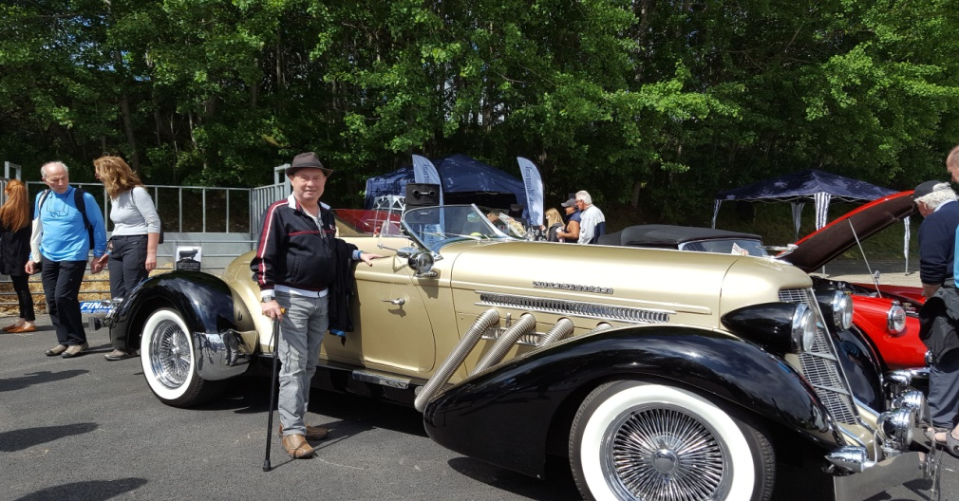
GOOD NEWS!

Digby Brown Xmas Card and Calendar Competition for those with a Brain Injury

This year we put in 3 entries from Brian Duncan, Chris Smith and Carol MacLeod. We are delighted to advise that Brian is once again one of the winners in the calendar competition with his “Ready to Rut” drawing of a stag.
WELL DONE BRIAN!!

What’s been going on?

Lochter Bar B Q
Our annual BBQ was at Lochter on Sunday 14th October. Over 40 members attended. The food was great (plenty of it as usual) as was the company. Most members tried their hands at fishing with a substantial number of fish caught. A great success – WE WILL BE BACK!
Speaker – John Dargie Local Solicitor
John spoke to us again on Wednesday October 17th giving a very informative and interesting talk on all aspects of Powers of Attorney, Guardianship, Wills and Trusts. Thereafter John hosted an open Q and A session with lots of good questions (and answers).

“Evita”
A good sized group of members gathered at HMT to see Evita on Saturday October 20th. A great show enjoyed by all. Ice creams were included which made the day.

BIG Drop-Ins
The next Drop In is this Friday 3rd November from 12 ‘til 3 and will be fortnightly thereafter throughout the winter. Details of the dates are listed below so that you can put them in your diary. Art and Laughter Therapy will be incorporated at alternate Drop Ins. This Friday is a Laughter Therapy session, so, come along, have a light lunch and a good laugh!! In December there will only be one Drop In, no Art or Laughter sessions but a good chance to chat before the Christmas break.
LAUGHTER THERAPY ART SESSIONS
November | Friday 2nd | November | Friday 16th
November | Friday 30th
December | Friday 21st | December | Friday 21st
January | Friday 11th | January | Friday 25th
February | Friday 8th | February | Friday 22nd
March | March 8th | March | Friday 22nd

If you would like to attend but transport is a problem please contact Ian on 01224 733941 and we will try to help.

Bowling:
Aberdeen bowling will continue to take place on the 1st Thursday of each month 7- 9PM at Codona’s at Aberdeen Beach. The next 2 months dates are 1st November and 6th December. If you would like to take part just turn up or contact Ian on 01224 733941.

Lady Carers Bar Supper
The next Lady Carers Supper is on Tuesday 27th November at The New Inn, Ellon at 7pm. All lady carers are invited and will be welcome. If you would like to come along get in touch with Christine Lewis on 07974855134.

Male Carers Meal
The male carers group continue in their quest to eat their way around the world. This month they meet at Chiquito’s in Union Square Friday 30th November at 7pm for a Tex-Mex meal.
All male carers are invited and will be welcome. If you would like to come along get in touch with John Cushine on 07966 417375

Future Events

November 18th
Visit to Peterhead Prison Museum
We are visiting the Museum for tour on Sunday 18th November. We will be meeting at the Museum @ 12.15 for our tour followed by a “Cuppie and Fine Piece”.
Unfortunately the tour guide will not be available that day but headsets will be available and there are information boards throughout the Prison. The Prison is accessible for wheelchairs but not electric wheelchairs.
Sounds like a great day out.
As some of our tour will involve us going outdoors please make sure you are wearing suitably and warm clothing.
If you would like to join us phone Ian as soon as possible on 01224 733941 as we need to advise numbers

November 21st
Speaker Dr Alex Czepulkowski
Topic – A Philosophy of Recovery
Alex will be talking about his personal ABI experience and his road to recovery thereafter. This promises to be a truly inspirational evening. Come Along!!
At Inchgarth Community Centre Wednesday 21st November at 7.30 p.m.

December 13th
BIG Christmas “Shindig”
Our annual Christmas event has now been confirmed.
Arrive at Bowling Reception 11.15
Dodgem Grand Prix 11.40
2 Course Christmas Meal 12.00
Karaoke 1.30
Bowling 2.30 ish
Indoor Crazy Golf is also available if you wish.
To book your place for this highlight of the BIG year please contact Ian on 01224 733941
Adjustments to 2018/19 Programme
Please note that the March and April dates are incorrect on the programme. The correct dates are 20th March and 17th April and NOT 21st and 18th as quoted. Sorry for the error.
Support groups:
The Aberdeen Momentum Social support group meets every Thursday at Momentum 1.30-3.00 PM and then on to the YMCA.
The BIG “Team Horizons” support group meets from 11 a.m. on the last Wednesday of each month at “The Fine Peace” Café just behind Horizons in Eday Road.
The Elgin support group meets the last Monday of the month at 11 AM at the Moray resource centre, Maisondieu Road, Elgin, IV30 1RX.

The Inverurie support group meets on the last Friday of the month in the Discussion Room at the Garioch Community Centre, Victoria Street, Inverurie, 1-3 PM.

For further details phone Ian (01224 733941), or Chris (07948 609783) for the Aberdeen groups, Lois for the Elgin group (01343551339) and Carol for the Inverurie group (07512667250).

BIG contact details
BIG group website: brain-injury-grampian.weebly.com
BIG group email: info.biggroup@gmail.com
BIG group mobile: 07532 186155
BIG group postal address: ℅ Digby Brown, 220 Union Street, Aberdeen, AB10 1TL
BIG is a registered charity, Scottish Charity number: SC032273

