BIG September Newsletter 2018

What’s been going on?
- BIG Annual Dinner – Palm Court
Our annual dinner on 13th June was a great evening. Over 50 members attended good food, good company and a real buzz on the evening. Thank you to Alisdair MacDonald who entertained us with the bagpipes as we awaited our meal.
- Disabled Carriage Driving
On a lovely sunny day (not like last year) we gathered at Maryculter Carriage Driving Centre for our annual visit. After a picnic lunch we were able to take carriage rides with Jane and Euan MacInnes. A very enjoyable day – a special mention for the children who attended Jessica, Lily and young Miller. They kept us all amused!
- A BIG thank you to the Health Sciences Students at RGU!!
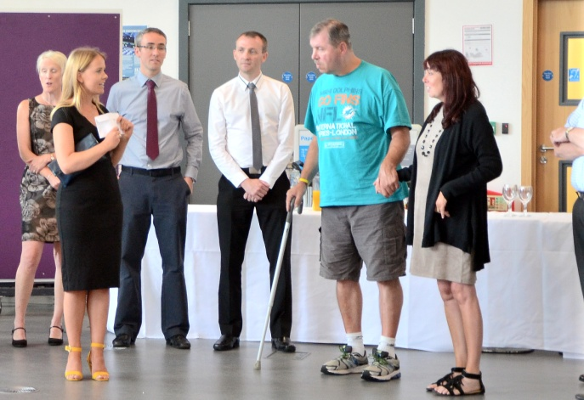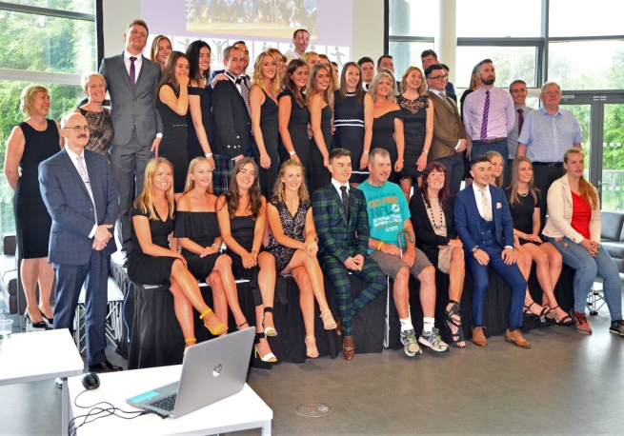
On 12th July we attended at RGU to receive a cheque for funds raised on our behalf by the students. We have a close relationship with the students and RGU with Gym Sessions each year from February to May. Paul Breen accepted the cheque on behalf of BIG. An amazing £1982.96 was raised on our behalf – to say we were stunned would be an understatement.
- Oor wee trip tae MacDuff
Finally took place on Saturday 4th August (almost a year after originally planned).
A bus trip to Banff with pick-ups, some retail therapy at the Spotty Bag Shop then lunch at the Banff Springs. After lunch a visit to the Marine Aquarium, a talk and dive show. Brilliant! – Amazing! – Super! Some of the members comments.

BIG Drop-Ins
The Drop In for 7th September has been cancelled as a group of members will be away on the BRAW weekend. The next scheduled Drop In is Friday 21st September and will be fortnightly throughout the winter. Art and Laughter Therapy will be incorporated alternatively commencing with Art on 21st.
If you would like to attend but transport is a problem please contact Ian on 01224 733941 and we will try to help.
Bowling:
Aberdeen bowling will continue to take place on the 1st Thursday of each month 7- 9PM at Codona’s at Aberdeen Beach. The next 2 months dates are 6th September and 5th October. If you would like to take part just turn up or contact Ian on 01224 733941.
Lady Carers Bar Supper
For detail on the next Lady Carers Supper please contact Christine Lewis on 07974855134.

Male Carers Meal;
The male carers group continue in their quest to eat their way around the world, meeting at Nargile Turkish Restaurant in Skene Street on 21st September at 7pm.
All male carers are invited and will be welcome. If you would like to come along get in touch with John Cushine on 07966 417375

2018/2019 Programme This is now ready and is attached to this Newsletter.

Future Events

September 19th (Wednesday)
Autumn Quiz Challenge
Come along and join us. Bring a team and challenge for the Joke Wardle Memorial Trophy. We have again secured the services of “world famous” quizmaster Carol Innes for a general knowledge quiz.
Good fun, good company, huge prizes?.
Meet at Inchgarth Community Centre 7.30 p.m.
October 7th
Our annual BBQ is at Lochter on Sunday 1st October at 12 noon. You can enjoy the lovely BBQ laid on and also if you wish you can try your hand at fishing. Please contact Ian John Cushine on 07966 417375 if you would like to attend and let him know if you would like to fish.
October 20th
HMT trip to see “Evita”
Thanks to funds received from the Bank of Scotland Foundation we have been able to purchase a batch of tickets (40) for Andrew Lloyd Webber’s production “Evita” on 20th October @ 2.30. Tickets will be allocated on a “First Come/First Served” basis. If you would like to join us please contact Jimmie on 07875 234891. Promises to be a great outing.
December 13th
A DATE FOR YOUR DIARY! Our BIG Christmas event at Codona’s. More detail in the October Newsletter!

Support groups:
The Aberdeen Momentum Social support group meets every Thursday at Momentum 1.30-3.00 PM.

The BIG “Team Horizons” support group meets from 11 a.m. on the last Wednesday of each month at “The Fine Peace” Café just behind Horizons in Eday Road.

The Elgin support group meets the last Monday of the month at 11 AM at the Moray resource centre, Maisondieu Road, Elgin, IV30 1RX.

The Inverurie support group meets on the last Friday of the month in the Discussion Room at the Garioch Community Centre, Victoria Street, Inverurie, 1-3 PM.

For further details phone Ian (01224 733941), or Chris (07948 609783) for the Aberdeen groups, Lois for the Elgin group (01343551339) and Carol for the Inverurie group (07512667250).

JAMES FALCONER IS RETIRING!!

Many of you will know James who was a founding member of BIG and a committee member until 2015. We have recently received this notice of his retirement which may be of interest.

James will be retiring from the Chaplaincy Department in NHS Grampian at the end of September 2018.
James began work as a Chaplain in Aberdeen Royal Infirmary and Royal Aberdeen Children’s Hospital on 18th November 1991, although he began his Chaplaincy career a few years previously at Kingseat Psychiatric Hospital. Although he is most associated with his work in ARI and RACH, we are also very grateful for all the innovative work he has done in Chaplaincy such as the Therapeutic Roof Garden, the Candle Service for those who have lost children in hospital and the Grampian Brain Injury charity. His long and valued contribution to Chaplaincy has been much appreciated.
We will be saying 'Goodbye' to James on Thursday 20th September at 2.30pm in the Chapel at ARI (Pink Zone, Level 2). Do join us for tea, coffee and refreshments if you are able. Let our Secretary Delaine Kennedy know by 10th September if you intend to come (contact details below).
From Monday 3rd September, a card will be available in Chaplaincy (Pink Zone, Level 2) for you to sign.
If you wish to make a donation for the purposes of a Presentation to James, you should send it, or hand it into Delaine in a sealed envelope marked "James" by 10th September. If you are contributing by cheque, please make it out to “The Chaplain’s Fund”.
With best wishes
Rev Mark Rodgers
Lead Chaplain/Head of Spiritual Care,
NHS Grampian, Chaplaincy Department,
Aberdeen Royal Infirmary, Foresterhill, Aberdeen, AB25 2ZN

BIG contact details

BIG group website: brain-injury-grampian.weebly.com
BIG group email: info.biggroup@gmail.com
BIG group mobile: 07532 186155
BIG group postal address: ℅ Digby Brown, 220 Union Street, Aberdeen, AB10 1TL
BIG is a registered charity, Scottish Charity number: SC032273

