BIG September Newsletter 2019

What’s been going on?

BIG Get Steaming with train driver Paul

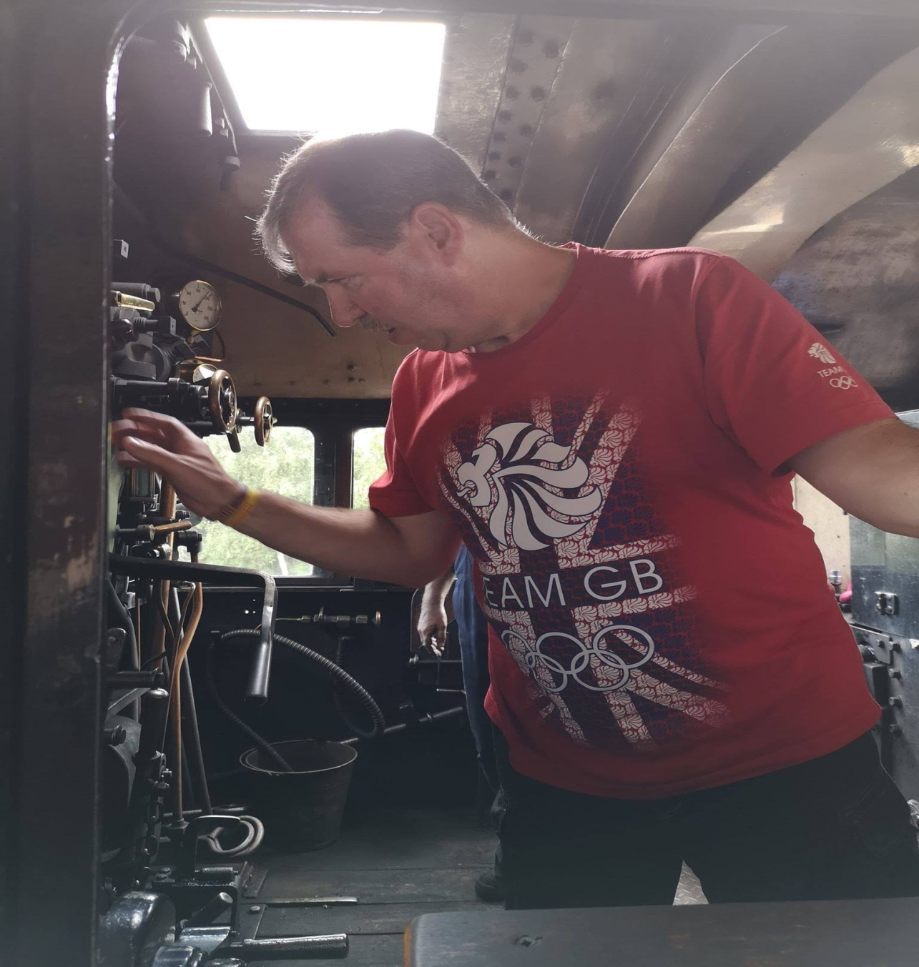

Our BIG Adventure for 2019 and the highlight of our summer programme was our trip to have afternoon tea on the Aviemore to Grantown on Spey steam railway on Sunday 4th August. 49 members enjoyed a really great day out. The bus passed through wonderful scenery on the way to Aviemore where we had time for a short walkabout and snack lunch before boarding the train and enjoying a lovely steam train ride. The afternoon tea was excellent and enjoyed by all. Paul Breen (a train driver prior to his Brain Injury) was given the opportunity to mount the footplate, speak with the driver and hoot the horn. A long day but a great outing enjoyed by all.

BIG Drop-Ins

Christine Kennedy and Jimmie Dickie have taken over the organisation and running of the fortnightly Drop-Ins. For the coming year they will be assisted by a team of volunteers – Colin and Jackie Main, Ann Crombie and Maureen Smith (Chris’ mother)
The normal fortnightly Drop-Ins will recommence on the 2nd Friday in September (13th) including a Music and Laughter session.
Art and Music and Laughter Sessions will be incorporated at alternate Drop Ins. The format will continue to be very informal – Tea, coffee, soup and sandwiches with the opportunity to have a chat, play games, pool etc and get involved in the Art/Laughter sessions if you wish, so, come along, have a light lunch and a good laugh!!

September | Friday 13th M&L | Friday 27th Art
October | Friday 11th M&L | Friday 25th Art

If you would like to attend or have any queries about the Drop-Ins please contact Christine on 01651 891771 or Jimmie on 07875 234891.

Bowling:
Aberdeen bowling will continue to take place on the 1st Thursday of each month 7- 9PM at Codona’s at Aberdeen Beach. The next 2 months dates are 5th Sept and 3rdOct. If you would like to be involved just turn up or contact David Bowie on 01224 732607.

Lady Carers Bar Supper
The next Lady Carers Supper is on Friday 13th September at Cornkist Ellon. Please give Christine Lewis a ring on 07974855134 for more info or if you are coming so she can get it booked. All female carers welcome.

Male Carers Meal
The male carers group’s next meal is on Friday 13th September at Maggie’s Grill 242 Holburn Street at 7pm. All male carers are invited and will be made very welcome. If you would like to come along and join us get in touch with Lennie McRobbie on 01224 826073

2019/2020 BIG Programme

A copy of the Social Support programme for 2019/20 is attached to this Newsletter. Inevitably there will be changes as the year progresses, but , as you will see there is a very busy year planned

Future Events

John McDonald Wall Climb 2nd September

One of our members is taking on an amazing challenge on Monday 2nd September.

See link below
https://www.justgiving.com/crowdfunding/john-macdonaldbig.

Scottish Head Injury Forum 5th September
The next SHIF event will be held in the Park Inn by Radisson Aberdeen Hotel at the Park Inn by Radisson Aberdeen (1 Justice Mill Lane, Aberdeen, AB11 6EQ) on 5th September from 9.30 ‘til 4.30

Scotland's first Major Trauma Centre opened in Aberdeen almost 1 year ago, the event programme will be exploring 'Travelling Through Trauma' with our speakers discussing the various stages involved in the patients journey.

ABI Survivors and Carers attend for free.

SPEAKERS FOR THE DAY INCLUDE:
- Martin Esposito - Clinical Effectiveness Lead - Major Trauma, Clinical Directorate, Scottish Ambulance Service
- Dr Maggie Whyte - Consultant Clinical Neuropsychologist, Aberdeen Royal Infirmary
- Chris Smith - Brain Injury Survivor
- Ian Crombie - Convenor of Brain Injury Grampian Group
A full programme of speakers and presentations will be available nearer the date
A free lunch is included. This is a good chance to replenish your supplies of stationery/pens/Sweeties etc at the various stalls.
Sounds like a good day. If you would like to attend contact Gemma on info@shif.org.uk

September 18th (Wednesday) Inchgarth 7.30pm
Autumn Quiz Challenge and talk by Monica Baseotto

Come along and join us. Bring a team and challenge for the Joke Wardle Memorial Trophy. We hope to, again, secure the services of “world famous” quizmaster Carol Innes for a general knowledge quiz.
Good fun, good company, huge prizes?.

Monica Baseotto will also be there to tell the group about her research into Values and Growth after an ABI. She will give a short presentation on her research and findings. She has interviewed a few members of BIG as part of her research. Please come along to help show our support.
BRAW 2019 September 20th to 22nd

As previously advised a group of members are attending the Headway Scotland BRAW weekend. We still have a couple of places available. Time is now short but if you would like to come along and enjoy a great weekend in good company please contact Ian on 01224 733941 ASAP

Lochter BBQ 13th October

The BIG annual BBQ and Fishing event will take place on Sunday 13th October at 12 noon. All welcome. Please contact Isobel on 0773902904 if you would like to book a place.

Lady Carers Weekend
Easter Bendochty, Blairgowrie – 25 to 28 October
Please note change of dates for this weekend.

These weekends have been a regular feature on our programme for quite a few years. Those who attend find the weekends very beneficial and a real break from their caring duties in the company of others with the same challenges at home.
We would love to welcome any new faces to our next weekend in October. You can join in the fun or relax on your own whatever you feel like doing.
Easter Bendochty House is really nice with lots of facilities and things to do.
The weekend is for 3 nights, but, if you would like to come only for 1 or 2 nights (or even just a day visit) then that is fine.
If you would like to find out more about the weekends and are interested in coming along give Isobel Buchan a ring on 07739029904 or email izzybuc@hotmail.co.uk

HMT trip to see “Cabaret”16th November

We have purchased a batch of tickets (40) for the musical “Cabaret” 16th November @ 2.30. Many of the tickets have already been allocated on a first come/first served basis to those who have attended recent Drop Ins and events. There are still as few tickets available, so, if you would like to come phone Ian or Ann Crombie on 01224 733941. If those wishing to attend exceeds the number of tickets we will keep a note on a waiting list as the numbers given for BIG events inevitably fluctuates as the event nears. This promises to be a great outing!!
It may also be possible but cannot be guaranteed that we will be able to purchase additional seats if required.

Support groups:

The BIG “Team Horizons” support group meets from 11 a.m. on the last Wednesday of each month at “The Fine Peace” Café just behind Horizons in Eday Road.
The Elgin support group meets the last Monday of the month at 11 AM at the Moray resource centre, Maisondieu Road, Elgin, IV30 1RX.
The Inverurie support group meets on the last Friday of the month in the Discussion Room at the Garioch Community Centre, Victoria Street, Inverurie, 1-3 PM.

For further details phone Ian (01224 733941), or Chris (07948 609783) for the Aberdeen group, Lois for the Elgin group (01343 551339) and Carol for the Inverurie group (07512 667250).

BIG contact details
BIG group website: brain-injury-grampian.weebly.com
BIG group email: info.biggroup@gmail.com
BIG group mobile: 07532 186155
BIG group postal address: ℅ Digby Brown, 220 Union Street, Aberdeen, AB10 1TL
BIG is a registered charity, Scottish Charity number: SC032273

