BIG April Newsletter 2019

BIG Members to get Steaming!!

For our main summer event this year on Sunday 4th of August we are arranging a coach trip to Aviemore to board the Strathspey Railway steam train on a return journey from Aviemore to Broomhill. Afternoon Tea will be served as we steam through the highlands.
More detail will appear in future Newsletters. The coach will leave from Aberdeen with various pick up points en route.
Sounds like a real BIG adventure!
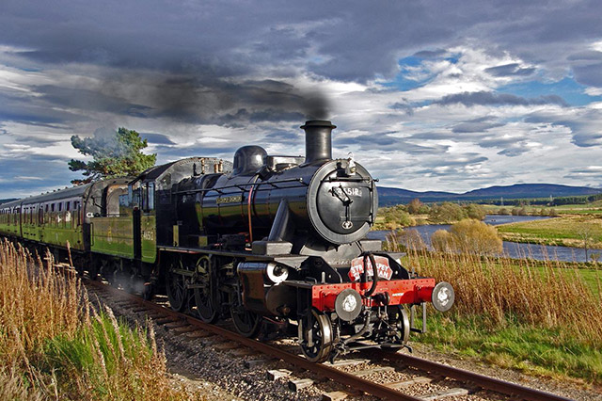
If you would like to book your place/places for this trip please contact Ian on 01224 733941.

What’s been going on?

March 20th
BIG Photography Group Evening (hosted by Peter Lewis)
Unfortunately the attendance on the evening was less than we would have anticipated, but nevertheless, Peter’s talk was very informative and some of his photo’s were absolutely stunning.
Chris Smith had collated a presentation of member’s photographs. Peter commented on the photo’s giving hints and tips on improvements that could be made.
The Photography Group (with Peter as guide) only had one outing last May to Haddo House. It is intended to have a further photoshoot provisionally set for the last Sunday in May. Further detail on location and other arrangements will appear in the next Newsletter.
We know that quite a few of our members are keen photographers. If you would like to participate please contact Chris on 07948 609783 or email him at cmswesthill@gmail.com

RGU
This year’s Gym sessions commenced on 15th February and will run on Fridays until 17th May. The sessions continue to be very well attended. The feedback from members has been extremely. There is no session on 5th April as the students are on holiday.

BIG Drop-Ins

Christine Kennedy and Jimmie Dickie have now taken over the organisation and running of the fortnightly Drop-Ins.

The next Drop In is Friday 5th April from 12 ‘til 3 and fortnightly thereafter as detailed below. Art and Laughter Therapy will be incorporated at alternate Drop Ins. The format is very informal – Tea, coffee, soup and sandwiches with the opportunity to have a chat, play games, pool etc and get involved in the Art/Laughter sessions if you wish, so, come along, have a light lunch and a good laugh!!

April | Friday 5th | Friday 19th
May | Friday 3rd | Friday 17th | Friday 31st
June | Friday 14th | Friday 28th

If you would like to attend or have any queries about the Drop-Ins please contact Christine on 01651 891771 or Jimmie on 07875 234891.

Bowling:
Aberdeen bowling will continue to take place on the 1st Thursday of each month 7- 9PM at Codona’s at Aberdeen Beach. The next 2 months dates are 4th April and 2nd May. If you would like to take part just turn up or contact David Bowie on 01224 732607.

Lady Carers Weekends
These weekends have been a regular feature on our programme for quite a few years. Those who attend find the weekends very beneficial and a real break from their caring duties in the company of others with the same challenges at home.
We would love to welcome some new faces to these weekends. You can join in the fun or relax on your own whatever you feel like doing.
There are 2 female carers weekends planned for this year. Craig Alvah Lodge at Banff from 10th to 13th May and Easter Bendochty in Blairgowrie from 4th to 7th October.
Both these properties are really nice with lots of facilities and things to do.
The weekends are for 3 nights, but, if you would like to come only for 1 or 2 nights (or even just a day visit) then that is fine.

If you would like to find out more about the weekends and are interested in coming along give Isobel Buchan a ring on 07739029904 or email izzybuc59@hotmail.co.uk Time is short for the May Weekend but if you would like to come please get in touch and we will try to accommodate you!

Lady Carers Bar Supper
For detail on the next Lady Carers Supper please give Christine Lewis a ring on 07974855134.

Male Carers Meal
The male carers group’s next meal is on Friday 5th April at the Ashvale Restaurant in Great Western Road (just off Holbourn Street) at 7pm.
All male carers are invited and will be very welcome. If you would like to come along and have a (Ashvale) whale of a time get in touch with John Cushine on 07966 417375

Future Events

April 24th at Inchgarth 7.30. (please note change of date!)
Rehabilitation and Support after a Brain Injury

Dr Helen Gooday, Director in Rehabilitation Medicine, Suzanne Livingston, Community Rehabilitation Nurse (Brain Injury Support) and James Anderson, Neuropsychologist at the Aberdeen Major Trauma Centre will speak to us on recent advances in Rehabilitation and Support for those with a Brain Injury and the operation of the new Major Trauma Centre. Should be an interesting night – come along!!

May 15th at Inchgarth 7.30
The 2019 Annual General Meeting

Notice is Hereby given that the 2019 Annual General Meeting of the Brain Injury Grampian (BIG) Group will be held at Inchgarth Community Centre on Wednesday 15th May at 7,30p.m.

This is a very important date in the calendar of our group. We assess how things have been going and how we should move forward. Our involvement is essential to the continuing health and development of BIG. We hope for a good turnout of members.
Please come along and also give some thought to whether you could in some way (large or small) help in the running and organisation of the group and our events.
An Agenda and 2018 Minutes will be issued in due course.

May 19th
Lochter Activity Day

Our popular annual Activity Day at Lochter is now arranged for Sunday 19th May.
The programme for the day:-

10.00 - Arrive at Lochter - Tea/coffee and bacon rolls on arrival
10.30 - Activity 1
11.15 - Activity 2
12.00 - Soup and Sandwich lunch served – Open Bar tab for soft drinks
12.30 - Fundraising Raffle
12.45 - Activity 3
13.30 - Activity 4
14.30 - Gather to learn scores and present Certificates
15.00 - Raffle Draw
15.15 app - Depart Lochter

The activities which will be available on the day are:-
- 4X4 Blindfold Driving
- Go Karting
- Digger Driving
- Archery
Fishing will also be available for those who wish it.
This is a family day open to BIG group members, their carers and families. If you would like to go contact Ian on 01224 733941as soon as possible but definitely before 5th of May as we have to confirm numbers to Lochter well before the date.

June 19th at Palm Court Hotel
BIG Group Annual Dinner

We are holding our very popular annual dinner again at the Palm Court. An informal 2 course meal in good company with good “craic”.
We meet at the hotel at 7p.m.
If you would like to attend give Ian a ring on 01224 733941.

September 20th to 22nd
BRAW 2019

A group of 13 members attended the Headway Scotland BRAW weekend at Tulliallan last year. Over 120 attended from various Headway Groups and BIG. The weekend was enjoyed by all.
Full details and an application form were attached to our March Newsletter. The cost for the weekend is £120 per head but BIG has reserved a number of places and will pay the deposit of £30 for those who wish to attend leaving a balance of only £90 to be paid for what promises to be a great weekend. There is also a £10 Single person supplement.
If the numbers wishing to attend exceeds our booked places we will try (but cannot guarantee) to secure further places.
Places will be allocated on a “first come – first served” basis, so, if this would be of interest to you please contact Ian on 01224 733941 ASAP and forward the application to him at, 76 Binghill Crescent, Milltimber, Aberdeen – AB13 0HU

And, Lastly!

We are currently working on our summer programme for 2019. We are investigating a trip to the “Wild West” in Lumphanan and it is also likely that we will, again, visit the disabled Carriage Driving Centre at Maryculter. More detail later.

Support groups:

The BIG “Team Horizons” support group meets from 11 a.m. on the last Wednesday of each month at “The Fine Peace” Café just behind Horizons in Eday Road.
The Elgin support group meets the last Monday of the month at 11 AM at the Moray resource centre, Maisondieu Road, Elgin, IV30 1RX.
The Inverurie support group meets on the last Friday of the month in the Discussion Room at the Garioch Community Centre, Victoria Street, Inverurie, 1-3 PM.

For further details phone Ian (01224 733941), or Chris (07948 609783) for the Aberdeen group, Lois for the Elgin group (01343551339) and Carol for the Inverurie group (07512667250).

BIG contact details
BIG group website: brain-injury-grampian.weebly.com
BIG group email: info.biggroup@gmail.com
BIG group mobile: 07532 186155
BIG group postal address: ℅ Digby Brown, 220 Union Street, Aberdeen, AB10 1TL
BIG is a registered charity, Scottish Charity number: SC032273

