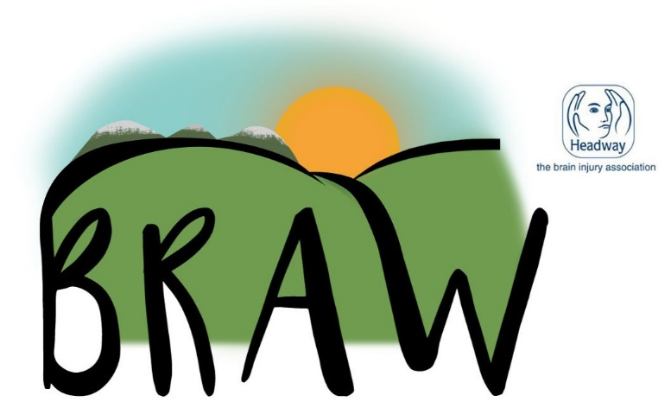
Best Relaxation & Activity Weekend 2019
Save the Date!
Friday 20th – Sunday 22nd September 2019
Tulliallan Police College
Tulliallan Castle, Kincardine FK10 4BE
Cost per person - £120.00 (additional £10 single person supplement) which includes accommodation, all meals & activities

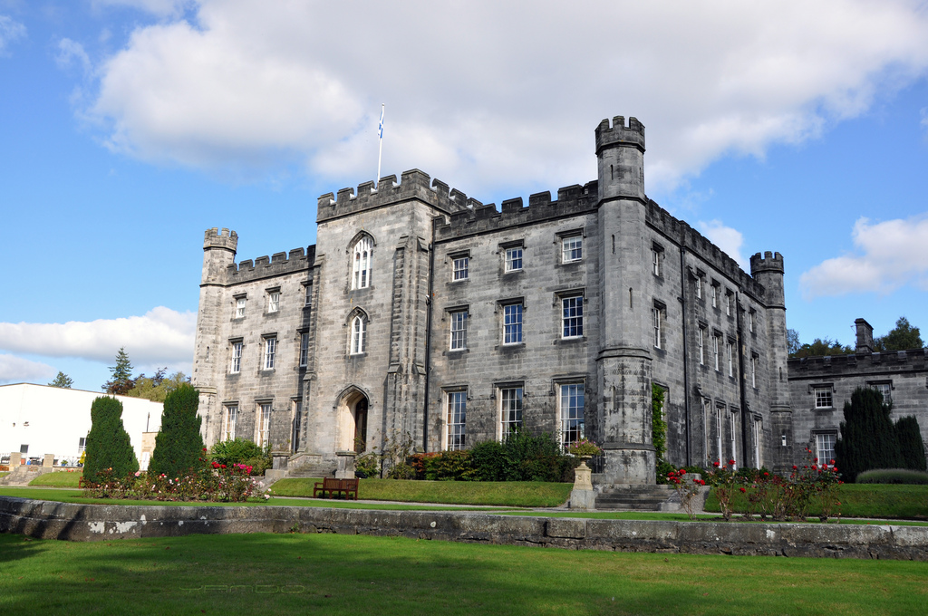

Draft Programme of events & booking information
Friday 20th – arrival & registration late afternoon
Welcome speeches, dinner, The Braw Factor & Disco
Saturday 21st – Morning - Option 1 – Falkirk Wheel trip
Option 2 – On site therapies & activities
Afternoon – Option 1 – Bo’ness & Kinneil Steam Railway trip
Option 2 - On site therapies & activities
Evening – Quiz, Raffle & entertainment from Fiona
Sunday 22nd – morning – Walking Football, New Age Kurling, Arts & Crafts & therapy options
Depart after lunch
Therapies
The BRAW committee are delighted to announce that we will once again be providing holistic therapies over the course of the weekend – last minute bookings will be taken after registration if spaces available. Some of the therapies that will be available are listed below:
Back, neck & shoulder massage
Reflexology
Mindfulness
Activities
Arts & Crafts
Guided walks
Outdoor Activities will be delivered by ‘Venturing Out’
Team Building / Problem Solving whilst orienteering: The activities will be tailored to group needs
Orienteering on its own: a variety of orienteering courses to suit varied abilities.
Bushcraft / Survival: Finding a way to collect water; building a shelter; hot chocolate on storm kettles; orienteering skills; code breaking; Improvised Archery - Shooting (Bows n Arrows); lighting a fire without matches or lighter
Taster Sessions: New Age Kurling, Boccia, walking football
Swimming in College swimming pool – non-supervised, confident swimmers only
All ability cycling will be delivered by Beyond Boundaries East Lothian

All staff will be qualified coaches and all appropriate safety equipment such as aids and helmets will be used.
Best Relaxation & Activity Weekend 2019
Booking Form
Personal Details
Are you a Brain Injury Survivor? ………………………………………………………………………….
Are you a carer? ……………………………………………………………………………………………
Are you a volunteer? ………………………………………………………………………………………
First Name …………………………………………………………………………………………………………………
Surname………………………………………………………………………………………………………
Address (inc postcode)………………………………………………………………………………………
………………………………………………………………………………………………………………
Telephone Number (inc code) …………………………………………………………………………………………………………………
Headway Group/Branch…………………………………………………………………………………………………
Date of Birth………………………………Male/Female ………………….………………………………
Who can we contact in an emergency?
Name…………………………………………………………………………………………………………
Relationship (e.g. sister, wife, partner etc)………………………………………………………………
Address………………………………………………………………………………………………………
…………………………………………………………………………………………………………………
Telephone…………………………………………………………………………………………………
Mobile or alternative number………………………………………………………………………………………………………
Medical Questions
Medical questions must be completed fully to ensure safe and efficient running of the event and the ‘Venturing Out’ activities. Details listed may be requested by emergency personnel but will otherwise remain confidential.
YES NO
Do you have diabetes?…………………………………………………………………………………
Do you have epilepsy?.......................................................................................................................................
If you answered Yes – Please tell us about the frequency and severity of epileptic seizures below:

Do you have any allergies? …………..………………………………………………………………
If you answered Yes – Please tell us about the allergies you have – (e.g. to food or drugs or other):
About Mobility
My walking ability is: Good ………………. With Aid …………………….Limited …………………
Wheelchair user: Electric ……………… Manual ………………………
Transfer method: Self without help ………With help (can weight bear) ……….with hoist ……….
All accommodation will be allocated on a priority/needs basis. Accommodation is in twin rooms; there are several accessible rooms available, please state requirements when booking and be aware that rooms will be allocated on a first come first served basis and thereafter a waiting list will be in operation. There are no single rooms but if requested due to specific stated needs then we will do our best to accommodate these individual needs. There will be an additional cost of £10.00 per person for the single rooms. The accommodation at Tulliallan is designed for students or Police Cadets and as such is basic; there may or may not be televisions or tea/coffee making facilities in your rooms; we do not have control over this and cannot guarantee these items.
I am part of a couple and prefer a twin room I would prefer to share with: (list names) ………………………………………………………………………………………………………………..
I require single accommodation (please state need) …………………………………………………………………………………………………………………
Please record any medication taken (you can attach a repeat prescription list) or aids required below:
Medication / aids ………………………………………………………………………………………………………………
Medical declaration: Are there any other medical issues that the organisers need to be aware of?
Enter details here or state Nil: …………………………………………………………………………………………………………………
Have you any special dietary requirements such as vegetarian, vegan, dairy free etc?
…………………………………………………………………………………………………………………
Please note: The organisers of BRAW19 cannot supply support workers or personal care workers to assist you during your weekend – if you require a support worker or help with your personal care then you must supply that support yourself.

Merchandise
Polo Shirts available to pre-order. We would prefer if you could pre-order & pay for merchandise at time of booking to avoid disappointment; polo shirts will be white and will display BRAW logo.
Polo Shirts @ £15.00 each – number of each size required S M L XL XXL
Order
Item | No | Type | Cost Paid
Ticket
 |  | Headway member @ £120.00
 |  | Volunteer @
 |  | Carer @
 |  | Professional @ £150.00
 |  | Day visitor @ £60.00
Merchandise |  | Polo Shirt @ £15.00
All rooms are twin bedded
Cost per person for 2 people sharing a twin room £120.00
Cost per person for 1 person requiring single occupancy £130.00
Total cost includes non–refundable deposit of £30.00 per person
Balance of £90.00/£100.00 (single) will be required 12 weeks prior to event and will be non-refundable after 6 weeks prior to event unless clear medical evidence is provided.
We would advise that you take out holiday cancellation insurance to cover your short break and check with your GP before taking part in any activities
Cheques to be made payable to Headway UK, please complete sections below & return to your group/branch co-ordinator or to Maria Burnett
Account Name | Account Number | Cheque Number
Final Checks!
Ensure all sections of the form are fully completed
Make out a cheque to Headway UK for the appropriate amount (if paying by cheque), ensure BRAW 19 and name of attendee on reverse
Make sure you have signed both parts of the form; media consent & box below.
Give the booking form & payment to your Headway group or branch contact
Group/branch Coordinator Instructions - please have non-refundable deposits and completed booking forms in to you by 5th April. Pay Headway UK as directed but forward booking forms to Maria Burnett below. Final payments will be due to be paid by 31st July with final details forwarded to Maria Burnett as before.
If you do not have a Headway group/branch contact please contact
Maria Burnett, Network Support Co-ordinator - East of Scotland
maria.burnett@headway.org.uk Telephone: 0115 924 0800 Mobile: 07826 519 567
Activity Booking

Please pre-book activities using the columns below, enter your name only, and we will try to accommodate your wishes as much as possible. You can only choose to go on one outing; either the Falkirk Wheel in the morning or The Bo’ness & Kinneil Steam Railway in the afternoon. Massage therapists will offer you a treatment based on your own needs & their recommendations during your appointment – this will include hand/arm, back, neck & shoulders, reflexology, Indian Head Massage etc. Mindfulness will also be on offer as participants have found this to be a very effective tool in managing stress & anxiety. Swimming, you will be given the key code along with your room codes on arrival. The all-ability bikes will be with us all day Saturday and Sunday morning for you to try at any time. Venturing Out activities will be available on the Saturday only. Arts & Crafts will be available as a drop in over the weekend.

 | Saturday AM | Saturday PM | Sunday AM | Wheelchair access required?
Falkirk Wheel |  | Not available | Not available
Bo’ness & Kinneil Steam Railway | Not available |  | Not available
Massage Therapies
Mindfulness
Swimming | Not available |  | Not available | Not available
Venturing Out activities |  |  | Not available

Booking confirmation
Please sign and date below that you have read & understood the terms & conditions and are booking your place on the BRAW 19 weekend

Signed
Dated

Consent to use of media
Please ensure you read the statement below and sign where appropriate if you agree.
I consent to pictures and/or recordings being made of me to advertise the event and to promote the work of Headway. These may be held on file and used later.
Signed
Dated

GDPR Statement
The 21st Century brings with its broader use of technology, new definitions of what constitutes personal data and a vast increase in cross-border processing.
Your privacy matters to us at Headway and to our BRAW event organisers – we will not use your data without your written permission. We intend to use such data as permitted for publicity and evaluation measures to promote the work of Headway and to enable us to provide you with a safe and secure weekend of activities geared towards your individual requirements.
By consenting to sharing your information with us and to this privacy notice you are giving us permission to process your data for the purposes identified.
You can withdraw any of the things you have agreed above at any time by writing to members of the organising committee detailed below.
Maria Burnett maria.burnett@headway.org.uk or Joyce Cattanach headwayeastlothian@live.co.uk
Or by post to GDPR Officer
Headway - the brain injury association
190 Bagnall Road
Nottingham
NG6 8SF
Administration Use only | Date received
Booking form
Deposit
Balance

