BIG May Newsletter 2019

The 2019 Annual General Meeting

The 2019 Annual General Meeting of the Brain Injury Grampian (BIG) Group will be held at Inchgarth Community Centre on Wednesday 15th May at 7,30p.m.

This is a very important date in the calendar of our group. We assess how things have been going and how we should move forward. Our involvement is essential to the continuing health and development of BIG. A good turnout of members is important so that we can get a broad range of views.
So please come along, participate and also give some thought to whether you could in some way (large or small) help in the running and organisation of the group and our events.
An Agenda for the AGM is attached. 2018 Minutes will be available on the evening.

What’s been going on?

Friday 5th April – Male Carers Meal
The male carers group met for their monthly meal at the Ashvale Restaurant in Great Western Road.
Colin Main took on the ultimate challenge by ordering the ASHVALE WHALE, renowned as the World’s Biggest Fish Supper. Colin rose to the occasion and is seen proudly holding his Certificate of Achievement. There is no truth to the rumour that the prize for succeeding was a large box of Rennie’s!!
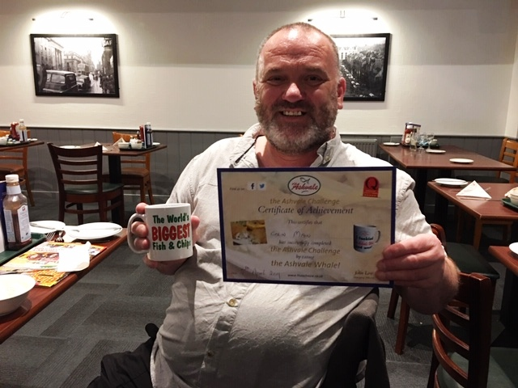

“WHALE” DONE COLIN!

April 24th at Inchgarth 7.30.

Dr Helen Gooday, Director in Rehabilitation Medicine, Suzanne Livingston, Community Rehabilitation Nurse (Brain Injury Support) and James Anderson, Neuropsychologist at the Aberdeen Major Trauma Centre spoke to us on recent advances in Rehabilitation and Support for those with a Brain Injury and the operation of the new Major Trauma Centre. The talks were really good giving an insight into how things are developing in Rehabilitation.
Unfortunately the turnout was low but, hopefully, we will have Dr Gooday and her team again at a future date to update on further initiatives.

RGU
This year’s Gym sessions finish on Friday 17th May. This year’s sessions have been very well attended and members have benefitted greatly from them. A huge THANK YOU to the staff and students at RGU

BIG Drop-Ins

Christine Kennedy and Jimmie Dickie have now taken over the organisation and running of the fortnightly Drop-Ins.

The next Drop In is Friday 17th May from 12 ‘til 3 and fortnightly thereafter as detailed below. Art and Music and Laughter Therapy will be incorporated at alternate Drop Ins. The format is very informal – Tea, coffee, soup and sandwiches with the opportunity to have a chat, play games, pool etc and get involved in the Art/Laughter sessions if you wish, so, come along, have a light lunch and a good laugh!!

May | Friday 17th | Friday 31st
June | Friday 14th | Friday 28th

During the summer months it is likely that we will only have one drop in each month in July and August with the fortnightly sessions recommencing in September. Full detail will be included in the Summer Newsletter.
If you would like to attend or have any queries about the Drop-Ins please contact Christine on 01651 891771 or Jimmie on 07875 234891.

Bowling:
Aberdeen bowling will continue to take place on the 1st Thursday of each month 7- 9PM at Codona’s at Aberdeen Beach. The next 2 months dates are 6th June and 4th July. If you would like to take part just turn up or contact David Bowie on 01224 732607.

Lady Carers Bar Supper
For detail on the next Lady Carers Supper please give Christine Lewis a ring on 07974855134.

Male Carers Meal
The male carers group’s next meal is on Friday 10th May at the Manchurian Restaurant at 136 Causewayend, AB25 3TN (just off the Mounthooley roundabout) at 7pm.
All male carers are invited and will be made very welcome. If you would like to come along and join us get in touch with John Cushine on 07966 417375

Future Events

May 19th
Lochter Activity Day

Our popular annual Activity Day at Lochter is on Sunday 19th May.
The full programme for the day was included in the April Newsletter. The day starts with Bacon Rolls at 10.o’clock and concludes with a prizegiving ceremony at approx 3.15.
The activities which will be available on the day are:-
- 4X4 Blindfold Driving
- Go Karting
- Digger Driving
- Archery
Fishing will also be available for those who wish it.
This is a family day open to BIG group members, their carers and families. Although we have now advised Lochter of numbers, if you would like to go but have not yet been in touch contact Ian on 01224 733941immediately and we will see if we can fit you in.

May 26th
BIG Photography Group Trip to Haddow House with Peter Lewis

The next Photography Group (with Peter as guide) outing to Haddo House has been provisionally set for the last Sunday in May. No detail yet but if you would like to participate please contact Chris Smith on 07948 609783 or email him at cmswesthill@gmail.com
We know that quite a few of our members are keen photographers, so, if you are one of them get in touch with Chris and join us on May 26th

June 19th at Palm Court Hotel
BIG Group Annual Dinner

Our very popular annual dinner is again at the Palm Court. An informal 2 course meal in good company with good “craic”.
We meet at the hotel at 7p.m.
If you would like to attend give Ian a ring on 01224 733941 as soon as possible.

Sunday 4th of August
Steam Train Trip with Afternoon Tea

For our main summer event this year we are arranging a coach trip to Aviemore to board the Strathspey Railway steam train on a return journey from Aviemore to Broomhill. Afternoon Tea will be served as we steam through the highlands.
We leave Aberdeen at 9.30 picking up at various locations arriving at Aviemore around 12.30

The projected timetable is:-
Bus leaves Spa Street Aberdeen 09.30
Westhill – Layby at Police Station 10.00
Inverurie – Town Hall 10.30
Huntly – ASDA car park (possible) 11.15
Aviemore – Walk round – bite of lunch 12.30 (ish)
Board Steam Train 14.45
Afternoon Tea 15.00
Return Aviemore 16.25
Bus to Aberdeen with Drop Offs 16.30

If you would like to book your place/places for this trip please contact Ian on 01224 733941 and indicate where you would like picked up.

September 20th to 22nd
BRAW 2019

A group of 13 members attended the Headway Scotland BRAW weekend at Tulliallan last year. Over 120 attended from various Headway Groups and BIG. The weekend was enjoyed by all.
Full details and an application form were attached to our March Newsletter. The cost for the weekend is £120 per head but BIG has reserved a number of places and will pay the deposit of £30 for those who wish to attend leaving a balance of only £90 to be paid for what promises to be a great weekend. There is also a £10 Single person supplement.
If the numbers wishing to attend exceeds our booked places we will try (but cannot guarantee) to secure further places.
Places will be allocated on a “first come – first served” basis, so, if this would be of interest to you please contact Ian on 01224 733941 ASAP and forward the application to him at, 76 Binghill Crescent, Milltimber, Aberdeen – AB13 0HU

And, Lastly!

The next Newsletter will be our Summer Newsletter issued around the middle of June.
This will contain our full summer programme and dates/arrangements for Drop Ins over the summer.

Support groups:

The BIG “Team Horizons” support group meets from 11 a.m. on the last Wednesday of each month at “The Fine Peace” Café just behind Horizons in Eday Road.
The Elgin support group meets the last Monday of the month at 11 AM at the Moray resource centre, Maisondieu Road, Elgin, IV30 1RX.
The Inverurie support group meets on the last Friday of the month in the Discussion Room at the Garioch Community Centre, Victoria Street, Inverurie, 1-3 PM.

For further details phone Ian (01224 733941), or Chris (07948 609783) for the Aberdeen group, Lois for the Elgin group (01343551339) and Carol for the Inverurie group (07512667250).

BIG contact details
BIG group website: brain-injury-grampian.weebly.com
BIG group email: info.biggroup@gmail.com
BIG group mobile: 07532 186155
BIG group postal address: ℅ Digby Brown, 220 Union Street, Aberdeen, AB10 1TL
BIG is a registered charity, Scottish Charity number: SC032273

The 2019 AGM of the BIG group will be held on Wednesday May 15th, at 7.30PM in Inchgarth Community Centre.

Agenda:
- Apologies
- Minutes of 2018 AGM
- Convenor’s report
- Treasurer’s report
- Update on Support Groups
- Election office bearers
- Election of committee members and ABI Representatives
- AOCB

Remember this is your group. Come along to contribute to the discussion, vote for new committee members and help develop our future.

