BIG October Newsletter 2019

What’s been going on?

Lady Carer’s Weekend

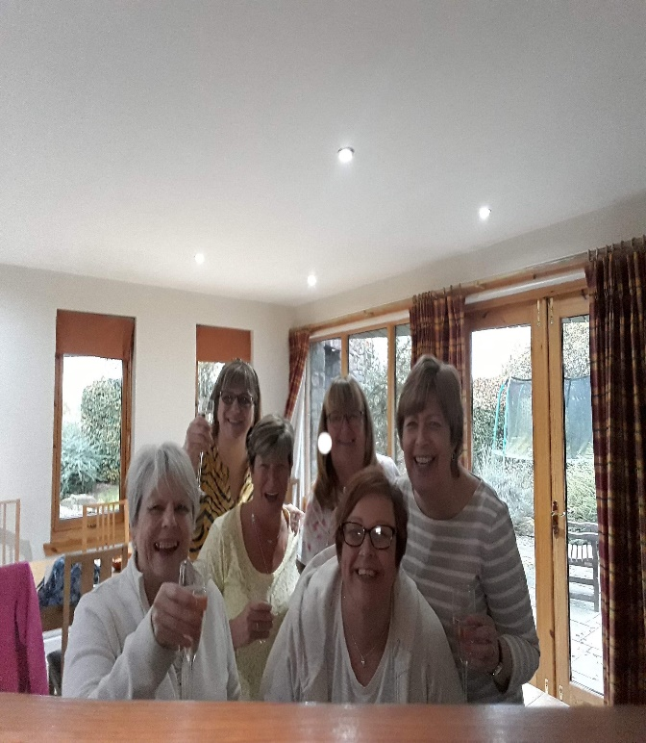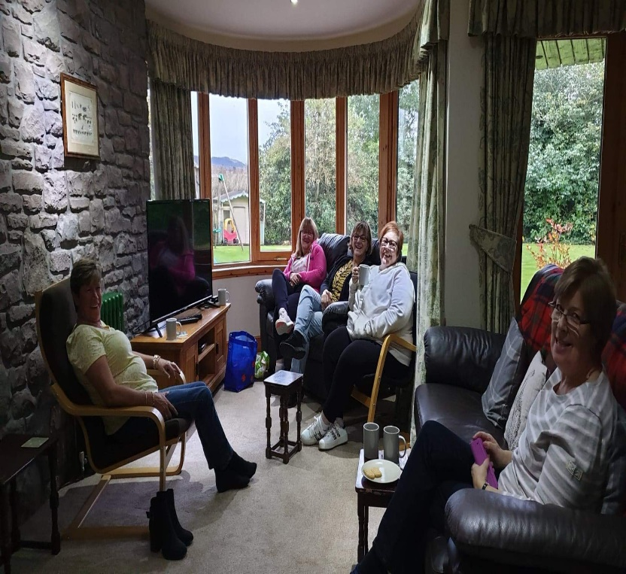

This year we returned to Easter Bendochy, Blairgowrie. Unfortunately only 6 managed this time but those who did thoroughly enjoyed the break. Lots of laughter, which the doctor always says is the best medicine. All felt their batteries were recharged and ready to go face the daily challenges again. It helps to speak to others going through similar struggles on a daily basis. The weekend can be what you want it to be. It would be great if more ladies could attend. Please get in touch with Isobel on 07739029904 if you want to know more about it.

Lochter BBQ
Our annual BBQ was at Lochter on Sunday 13th October. 43 members attended. The food was great (plenty of it as usual) as was the company. Most members tried their hands at fishing but the fish were more difficult to catch this year. Once again a great day out thoroughly enjoyed by all – WE WILL BE BACK!

Speaker – John Dargie Local Solicitor
John spoke to us again on Wednesday October 16th. He gave very informative and interesting talk on all aspects of Powers of Attorney, Guardianship, Wills and Trusts. Thereafter John hosted an open Q and A session with lots of good questions. Lot’s of good tips were given to members
Coming Soon
November 20th at Inchgarth 7.30.
Dr Helen Gooday, Director in Rehabilitation Medicine, Suzanne Livingston, Community Rehabilitation Nurse (Brain Injury Support) and James Anderson, Neuropsychologist at the Aberdeen Major Trauma Centre return to speak to us on recent advances in Rehabilitation and Support for those with a Brain Injury and the operation of the new Major Trauma Centre.
Unfortunately, the turnout was very low when Dr Gooday and her team spoke to us in April. The talk was very good so we have invited them back in November.
We hope for a good turnout this time, so, take a note in your diary and join us on the 20th for what promises to be an interesting talk.
December 12th 2019
BIG Christmas “Shindig”
Our annual Christmas event has now been confirmed.
Arrive at Bowling Reception 11.15
Dodgem Grand Prix 11.40
2 Course Christmas Meal 12.00
Karaoke 1.30
Bowling 2.30
Indoor Crazy Golf is also available if you wish.
To book your place for this highlight of the BIG year please contact Jimmie Dickie on 07875 234891
Male Carers Meal
The male carers group’s next meal is on Friday 8th November at the Selera Malaysia Bistro in Correction Wynd at 7pm.
All male carers are invited and will be made very welcome. If you would like to come along and join us get in touch with Colin Main on 07914728864

Lady Carers Meal

Lady Carer’s meal is going to be at 7 pm on the last Friday of every month starting Friday 31st January 2020 at Buchan Hotel Ellon. Please contact Christine Lewis on 07974855134 for more info or if you intend going so she can get it booked. All female carers welcome.

BIG Drop-Ins

Christine Kennedy and Jimmie Dickie have taken over the organisation and running of the fortnightly Drop-Ins. For the coming year they will be assisted by a team of volunteers – Colin and Jackie Main, Ann Crombie and Maureen Smith (Chris’ mother)
The normal fortnightly Drop-Ins will recommence on the 2nd Friday in September (13th) including a Music and Laughter session.
Art and Music and Laughter Sessions will be incorporated at alternate Drop Ins. The format will continue to be very informal – Tea, coffee, soup and sandwiches with the opportunity to have a chat, play games, pool etc and get involved in the Art/Laughter sessions if you wish, so, come along, have a light lunch and a good laugh!!

November | Friday 8th M&L | Friday 22nd
December | Friday 6th M&L | Friday 20th
January |  | Friday 17th

If you would like to attend or have any queries about the Drop-Ins please contact Christine on 01651 891771 or Jimmie on 07875 234891.

Bowling:
Aberdeen bowling will continue to take place on the 1st Thursday of each month 7- 9PM at Codona’s at Aberdeen Beach. The next 2 months dates are 7th November and 5th December. If you would like to be involved just turn up or contact David Bowie on 01224 732607.

HMT trip to see “Cabaret”16th November

All tickets now allocated but there is a waiting list if you want to add your name

We have purchased a batch of tickets (40) for the musical “Cabaret” 16th November @ 2.30. Many of the tickets have already been allocated on a first come/first served basis to those who have attended recent Drop Ins and events. There are still as few tickets available, so, if you would like to come phone Ian or Ann Crombie on 01224 733941. If those wishing to attend exceeds the number of tickets we will keep a note on a waiting list as the numbers given for BIG events inevitably fluctuates as the event nears. This promises to be a great outing!!
It may also be possible but cannot be guaranteed that we will be able to purchase additional seats if required.

Support groups:

The BIG “Team Horizons” support group meets from 11 a.m. on the last Wednesday of each month at “The Fine Peace” Café just behind Horizons in Eday Road.
The Elgin support group meets the last Monday of the month at 11 AM at the Moray resource centre, Maisondieu Road, Elgin, IV30 1RX.
The Inverurie support group meets on the last Friday of the month in the Discussion Room at the Garioch Community Centre, Victoria Street, Inverurie, 1-3 PM.

For further details phone Ian (01224 733941), or Chris (07948 609783) for the Aberdeen group, Lois for the Elgin group (01343 551339) and Carol for the Inverurie group (07512 667250).

BIG contact details
BIG group website: brain-injury-grampian.weebly.com
BIG group email: info.biggroup@gmail.com
BIG group mobile: 07532 186155
BIG group postal address: ℅ Digby Brown, 220 Union Street, Aberdeen, AB10 1TL
BIG is a registered charity, Scottish Charity number: SC032273

